The Engineering Profession
Practice and Responsibilities

Lecturer 2
Communication Skills

Items of the Lecturer:
- Written Communication
- Guidelines for Effective Writing
- Organization of a Scientific Document
- Factors Affecting Scientific Documents
- Guidelines for Effective Verbal Communication
- How to prepare your presentation?
- Making the presentation
- Factors Affecting PowerPoint presentation

Written Communication
- Written Communication such as technical reports and papers.
- Verbal Communication (listen and talk).
- Without Visual Aids such as Interviews.
- Without Visual Aids such as PowerPoint presentations.
Guidelines for Effective Writing
- Focus on why you are writing.
- Focus on your Reader.
- Satisfy Document Specifications.
- Get to the Point.
- Provide Accurate Information.
- Present Your Material Logically.
- Make Your Ideas Accessible.
- Format Your Pages carefully.
- Use Lists for some information.
- Use Efficient Wording.
- Edit at Different Levels.
- Spelling & Punctuation.
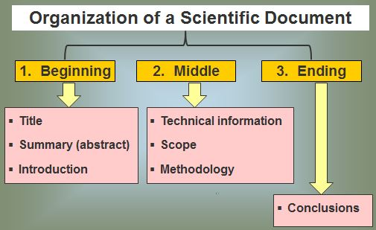
- Sentence Structure & Grammar.

Factors Affecting Scientific Documents
- Content and Depth of subject.
- Style (how to communicate the content to the audience).
- Form (format and mechanics):
- Grammar.
- Punctuation
- Spelling.
Verbal Communication
The choice of words, voice, tone and non-verbal clues (e.g. Body language, emotion of the sender and receiver) affects verbal communication.
According to research, in conversation or verbal exchange:
- Words are 7% effective.
- Tone of voice is 38% effective.
- Non-verbal clues are 55% effective.
Non-verbal clues
- Body language (e.g., arms crossed, standing, sitting, relaxed, tense).
- Emotion of the sender and receiver (e.g., yelling, speaking provocatively).
- Other connections between the people (e.g., friends, enemies, professional similarities or differences, age similarities or differences, philosophical similarities or differences, attitudes, expectations).
Guidelines for Effective Verbal Communication
- Make your message understood.
- Receive/understand the intended message sent to you.
- Exert some control over the flow of the communication.
- Prepare the structure of the talk carefully and logically, just as you would for a written report.
- Ask yourself and make a list of the following two things as your starting point:
- What are the objectives of the talk?
- What are the main points you want to make?
- You must learn to listen as well as to speak.
How to prepare your presentation?
- Analyze your audience.
- Determine your time frame.
- Identify your key points.
- Write out the presentation in rough (first draft of a written report). Review the draft and delete irrelevant vague or superfluous things. Check consistency and smooth flow.
- Create supporting graphics.
- Choose an organizational plan. Presentation can be broken down into introduction, main points and conclusion.
- Prepare an outline and notes (Cue Cards):
- Contain key words and phrases. Postcards are ideal (number the cards in case you drop them).
- Never read from a script. If you don’t know most of what you want to say, you should not be giving the talk.
- Rehearse your presentation:
- First to yourself and then in front of some colleagues.
- The initial rehearsal should consider how the words and the sequence of visual aids go together (effective use of your visual aids).
Making the presentation
- Appearance
- Dress appropriately for the occasion.
- First impressions influence the audience’s attitudes to you.
- Great the audience and tell them who you are
Good presentations then follow this formula:
- Tell the audience what you are going tell them.
- Then tell them.
- At the end tell them what you have told them.
- Speak clearly
- Don’t shout or whisper (judge the acoustics of the room).
- Don’t rush or talk deliberately slowly. Be natural.
- Don’t speak monotonously.
- Make clear transitions.
- Deliberately pause at and repeat key points (emphasizes the importance of a particular point you are making).
- Change your delivery, but not to obviously (to make the presentation interesting)
- Speed.
- Pitch of voice.
- Controlled Body Language (your movements express what your attitudes and thoughts really are):
- Use your hands to emphasize points but don’t indulge in too much hand waving.
- Maintain eye contact
- Look at the audience as much as possible, but don’t fix on an individual.
- Don’t block the screen.
- Don’t face the display screen behind you and talk to it.
- Don’t read from notes.
- Keep to the time allowed:
- If you can, keep it short. It’s better to under-run than over-run.
- As a rule, allow 2 minutes for each general overhead transparency or PowerPoint slide you use.
Factors Affecting PowerPoint presentation
- Content.
- Style.
- Graphics.
- Video Clips.
- Timing.

“How & What”
- What you say is not nearly as important as How you stay it
- A dull message delivered by a charismatic person, filled with energy will be accepted as brilliant.
- An excellent message delivered by someone who is not interesting in the topic, will not engage the enthusiasm of its intended audience.

